PERSONAL PROFILE
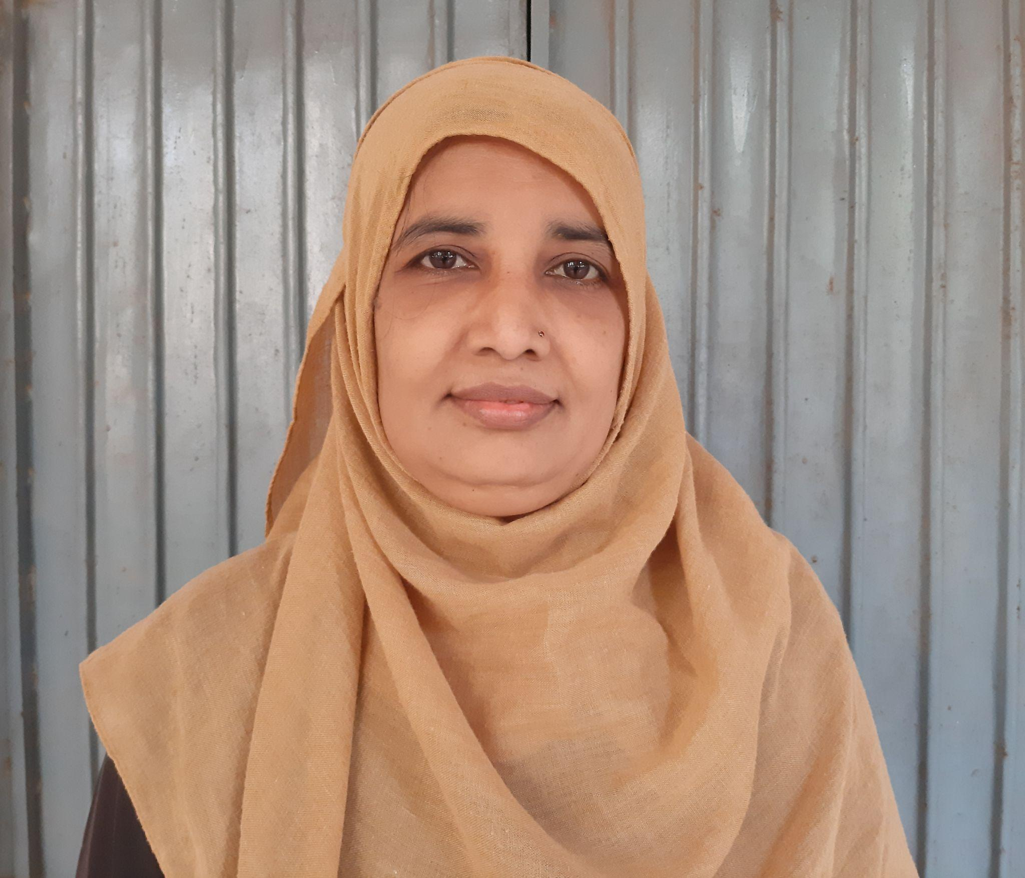

Name: Rasiqa Fathima
Designation: Lecturer in History
Qualification: M.A, B.Ed.
Experience: 2 years
Hobbies: Story writings for AIR Vijayawada & reading books
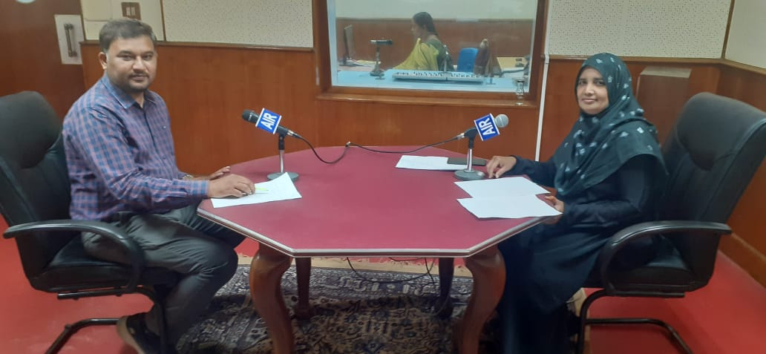
CellNo: 9848675911
Mail Id: rasiqafathima7@gmail.com
EDUCATIONAL QUALIFICATION
S.NO | COURSE | BOARD/  UNIVERSITY | YEAR OF  PASSING | PERCENTAGE
1 | S.S.C. | BOARDOF  SECONDARY  EDUCATION | 1993 | 55%
2. | INTERMEDIATE | BOARDOF  INTERMEDIATE  EDUCATION | 1995 | 53.5%
3 | B.A  (Public administration, sociology, Urdu literature) | DR.B.R AMBEDKAR OPEN UNIVERSITY | 2000 | 55%
4 | B.Ed. | ACHARYA NAGARJUNA UNIVERSITY | 2007 | 65%
5 | MA (History) | MAULANA AZAD NATIONAL URDU UNIVERSITY | 2009 | First class
6 | MA(URDU) | MAULANA AZAD NATIONAL URDU UNIVERSITY | 2010 | First class

Professional Experience:
1. Worked as a Guest Teacher in Urdu and history at A.P Residential girls minority school,
Vijayawada. (2003-2020)
2. Joined as a guest Lecturer in History in SRR & CVR Government Degree College.
Workshops attended:
International/National:
- Research methodologies of contemporary times: English language, Literature and Teaching organized by department of English on 5th February 2022.
- Health-Lifestyle Management a one day National Webinar organized by the physical education, SRR & CVR government degree college on 17th Feb 2022.
- National intellectual property awareness mission organized by intellectual property office, INDIA on 28 February, 2022.
- Importance of Intellectual property rights in higher education institutions organized by Department of commerce on 6th may 2022.
- Women Entrepreneurship opportunities and challenges organized by department of economics on 26th august 2022.
- Sports nutrition diet and reforming Eating Habits organized by physical education SRR & CVR GDC (A), with QUA nutrition on 27th august 2022.

